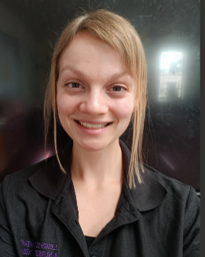 | 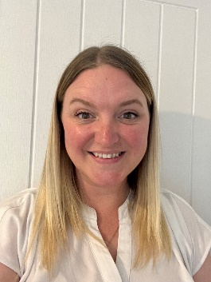 | 
Miss Caddell – 2C | Miss Fox - 2F | Mrs Street – 2S
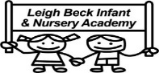

The children enter school via the side entrance next to the Transport Museum from 8:30 – 8:40am. We will welcome the children into school in the morning. Any messages will be passed onto the class teachers.
From Monday to Thursday, the school day ends at 3:10pm but there is a flexible pick-up time of 3:10pm-3:15pm. 2C will be seen out from their exterior classroom door on the corner. 2F will exit via their exterior door which is next to the main office door. 2S will leave via the double white doors on the end of the corridor (opening out onto the exterior courtyard). On Fridays, the school day will end at 2pm. If you wish your child to remain onsite until 3:15pm, they will join an after school club, to which there is a charge. Further information about this has been emailed out previously and can be obtained from the office.

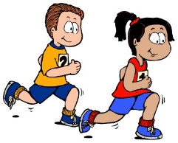
PE
In Year 2 we have two PE sessions per week. One session is outdoors on a Tuesday and the children will need shorts, t-shirt, jogging bottoms, jumper and trainers/plimsolls. The second session is indoors on a Thursday and the children will need shorts and a t-shirt. PE is compulsory and any children not wearing the correct PE kit will be asked to change. Long hair must be tied up and no earrings are allowed.
Unfortunately, earrings are not allowed to be covered in tape for PE lessons.


Topic
Our first topic in Year 2 is ‘Lost in London’. We will be learning about different landmarks in London and looking at the Royal Family. We will also learn important DT skills as we design and make our own London landmarks.
School Trips
We will be visiting Boydell’s Farm in the summer term in 2026 and we also welcome a range of visitors linked to our topics throughout the year.

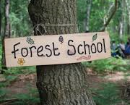
Forest School
The children will continue with their forest school sessions throughout the year. Children will need wellies and old clothes for these sessions.


Growth Mindset
In Year 2, we encourage the children to have a growth mindset and this is modelled to the children in every lesson by the adults. It is important for the children to be resilient and understand that we learn from our mistakes.

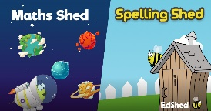
Online Learning Platforms
Each child will have their own login for Spelling Shed and Purple Mash. We use these programmes in school and the children are also able to access these at home. This supports them with their weekly spellings and development of curriculum skills.

Homework
In Year 2 we encourage every child to read at least 3 times a week at home. We reward their commitment to this reading challenge and each class has the opportunity to win the reading bear for their classroom.
Every child is given 10 weekly spellings to learn. We learn the spelling patterns in school but we also encourage children to practise their spellings at home. This can be done on Spelling Shed or in their spelling book. Weekly spellings are given out on a Friday and a spelling test is completed the following Friday.
Maths homework will be set weekly on Purple Mash and children are encouraged to complete the work. This is also set on a Friday and due in the following Friday.
Playground
In Year 2, the children have the opportunity to use the Trim Trail, the pirate ship climbing apparatus, the field (weather permitting) or playing games using the small equipment. The children will continue to be offered a piece of fruit at playtime.

Lunchtime
The children will continue to eat their lunch in the front hall. We would like to remind you that we are a Healthy School and we encourage the children to eat a healthy lunch. Please do not put fizzy drinks or chocolate bars in packed lunch boxes.
Wellbeing
In Year 2, we value the children’s wellbeing and the importance of allowing children the opportunity to relax. We have daily mindfulness sessions and regular circle times where we are able to discuss and manage issues and worries that are important to us. We also cover the importance of friendships, being respectful and having good manners.

We are really looking forward to working with you all next year. Please feel free to put a note in your child’s reading diary or speak to us at the door after school if you have any questions.

Year 2 Highlights
Opportunity to represent the school in sporting events at Deanes.
A chance to sing at the infant music festival.
A chance to be a playground friend!

